RSEA Foundation Scholarship Awarded
The RSEA Foundation proudly announces our first ever scholarship winner, Danielle Schexnayder from Port Barre, LA. Danielle is a senior at Northwestern State University and plans to graduate in August, 2021 with a Bachelor of Science in Nursing. After graduation she plans to work in the critical care or emergency care setting for two years. This will give her the experience she needs to go back to graduate school to become a certified registered nurse anesthetist (CRNA). Danielle was sponsored by her grandfather, Charles Daniels, who has been an RSEA member since 2011.
This Scholarship was made possible by the many RSEA members who generously donated money to the Scholarship Fund. The $1000 was funded from accrued interest and no principal was used.
Our thanks to our other applicants who made our decision hard. Unfortunately, we were only able to award one scholarship this year. Maybe, in future years we can build the fund up to where we can award more than one. Please pass on information about our scholarship to anyone who might meet the criteria for next year. You can find information on our Scholarship on our website, https://www.rseala.org or you can call us at the office at 225/930-0961 or you can email us at janthony.rsea@gmail.com.
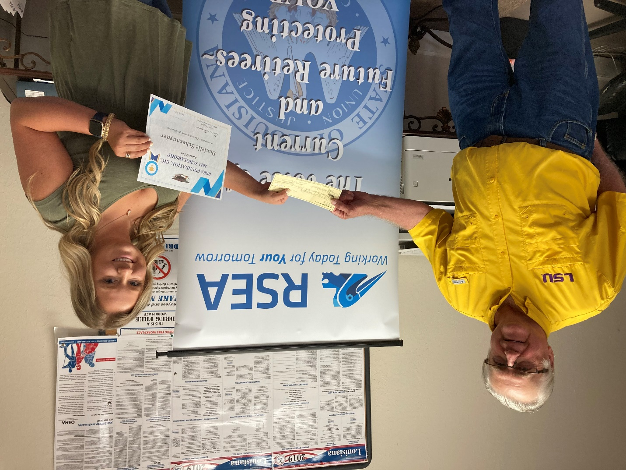RSEA Administrative Director, Jimmy Anthony handing the scholarship check to Danielle Schexnayder.

Danielle Schexnayder and her grandfather, Charles Daniels
